Multimedia Systems and Applications

Speech Processing F74054033 吳郁晨

- Sample speech signal via sound card (Pronounce 多媒體系統與應用 in Chinese using continuous speech)
- Speech signal analysis in Time Domain
- Waveform
- Energy contour
- Zero-crossing rate contour
- End point detection
- Pitch contour
- Present the program code, the methods you used and the results
- Submission due: Two weeks after the project is assigned.
輸出結果
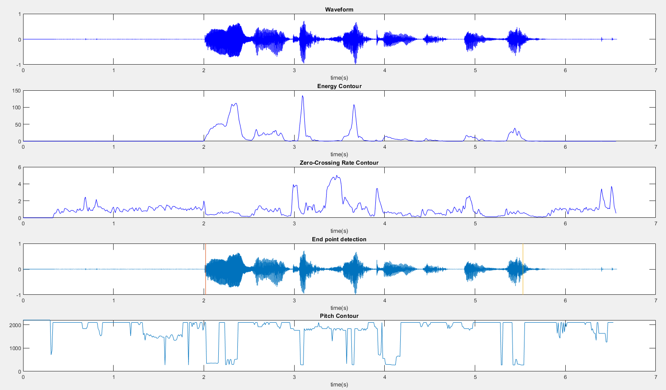
https://imgur.com/a/S4Y0UWR

CODE：

Project1.m
clear('all');
close('all');
[y,fs] = audioread('TEST.wav');
max_value = max(abs(y));
y = y/max_value;
frame_size = 20;
frame_shift = 10;

%%%%%%%%%%%%%%%%%%%%%%%%%%%%%%%%%%%%%%%%%%%%%%%%%%%%%%%%%%%%%%%%%%%%%%%%%%%%%%%%%

waveform_func(y,fs); %1

%§Q¥Î audioread ¨ÓÅª¨úµ¼ÖÀÉ ¨Ã±N¼Æ¾Ú¦s©ó[y,fs]

%%%%%%%%%%%%%%%%%%%%%%%%%%%%%%%%%%%%%%%%%%%%%%%%%%%%%%%%%%%%%%%%%%%%%%%%%%%%%%%%%

ec = energy_contour_func(y,fs,frame_shift); %2
zcr = zero_crossing_rate_contour_func(y,fs,frame_size,frame_shift); %3

%%%%%%%%%%%%%%%%%%%%%%%%%%%%%%%%%%%%%%%%%%%%%%%%%%%%%%%%%%%%%%%%%%%%%%%%%%%%%%%%%

end_point_detection_func(y,fs,frame_shift,frame_size); %4

%func¤º¦]¬°ÁÙ¬O·|¥Î¨ì ec.zcr ¦ý¦]¬°¨âªÌ¤º®e¤Ó¦h ¦ü¥G¤£¯à¶Ç ¦]¦¹¦bfunc¤º³¡¦A©I¥s¤@¦¸2 3 ÃDªºfunc

%%%%%%%%%%%%%%%%%%%%%%%%%%%%%%%%%%%%%%%%%%%%%%%%%%%%%%%%%%%%%%%%%%%%%%%%%%%%%%%%%

pitch_contour_func(y,fs); %5

%http://notedetection.weebly.com/center-clipping.html
%²Ä¤G¨BÆJªººâec¸ò²Ä¤GÃD¤@¼Ë ¥u¬On¥Îclipping«áªº°Ñ¼Æ

waveform_func.m
function [] = waveform_func(y,fs)

time=(1:length(y))/fs;
subplot(5,1,1);
plot(time, y,'b'); %1
title('Waveform');
xlabel('time(s)');

end

energy_contour_func.m
function [ec] = energy_contour_func(y,fs,frame_shift)

frame_shift = frame_shift/1000 * fs;
energy = 0;
t1 = (1:frame_shift:length(y) - frame_shift) / fs;
temp = 0;

for i = 1:length(t1)
for j = ((i-1) * frame_shift+1):(i+1) * frame_shift
if j <= length(y)
temp = temp + y(j).^2;
end
end
energy(i) = temp;
temp = 0;
end

subplot(5,1,2);
plot(t1,energy,'b');
title('Energy Contour');
xlabel('time(s)');
ec = energy;
end

zero_crossing_rate_contour_func.m
function [z] = zero_crossing_rate_contour_func(y,fs,frame_size,frame_shift)

frame_shift = frame_shift/1000 * fs;
zcr = 0;
temp = 0;
t1 = (1:frame_shift:length(y) - frame_shift) / fs;

for i = 1:length(t1)
for j = ((i-1) * frame_shift+2):(i+1) * frame_shift
if j <= length(y)
if(y(j-1) * y(j) < 0)
temp = temp + 1;
end
end
end
zcr(i) = temp / (2 * frame_size);
temp = 0;
end

subplot(5,1,3);
plot(t1,zcr,'b');
title('Zero-Crossing Rate Contour');
xlabel('time(s)');
z = zcr;

end

end_point_detection_func.m
function [] = end_point_detection_func(y,fs,frame_shift,frame_size)

ec = energy_contour_func(y,fs,frame_shift);
zcr = zero_crossing_rate_contour_func(y,fs,frame_size,frame_shift);
avg_energy = sum(abs(ec)) / length(ec);
ITU = avg_energy;

for i = 1:length(ec) - 1
if(ec(i) < ITU)
if(ec(i + 1) > ITU)
begin_p = i;
break
end
end
end

for j = length(ec):-1:2
if(ec(j) < ITU)
if(ec(j - 1) > ITU)
end_p = j;
break
end
end
end

t = 1/fs:1/fs:(length(y)/fs);
subplot(5,1,4);
plot(t,y);
hold on;
plot([(begin_p * (length(y)/fs)/length(ec)),(begin_p * (length(y)/fs)/length(ec))],[-1,1]);
hold on;
plot([(end_p * (length(y)/fs)/length(ec)),(end_p * (length(y)/fs)/length(ec))],[-1,1]);
hold off;
title('End point detection');
xlabel('time(s)');
end

pitch_contour_func.m
function [] = pitch_contour_func(y,fs)

%cal Pitch
frame_size = 30;
frame_shift = 10;
max_value=max(abs(y));
y=y/max_value;
window_period = frame_size / 1000;
window_length = window_period*fs;
shift_period = frame_shift / 1000;
sample_shift = shift_period*fs;
pitch_freq = 0;

sum1 = 0;autocorrelation = 0;sample_no = 0;
for i = 1:(floor((length(y))/sample_shift)-ceil(window_length/sample_shift)) % for setting the window size in short term
k = 1;yy = 0;
for j = (((i-1)*sample_shift)+1):(((i-1)*sample_shift)+window_length) % copy data in short term
yy(k) = y(j);
k = k + 1;
end
for l = 0:(length(yy) - 1) % calculate the pitch
sum1 = 0;
for u = 1:(length(yy) - l)
s = yy(u)*yy(u + l);
sum1 = sum1 + s;
end
autocor(l + 1) = sum1;
autocorrelation(l + 1,i) = autocor(l + 1);
end
auto = autocor(21:160);
max1= 0;
for uu = 1:140
if(auto(uu)>max1)
max1 = auto(uu);
sample_no = uu;
end
end
pitch_freq(i) = 1/((20+sample_no)*(1/fs));
end
[rows,cols] = size(autocorrelation);
pitch_t = 1/fs:shift_period:(cols*shift_period);
subplot(5,1,5);
plot(pitch_t,pitch_freq,'-'); % plot pitch contour
title('Pitch Contour');
xlabel('time(s)');
end

大略解釋(大部分都在CODE註解，但貼過來變成亂碼，用MATLAB打開即可)
Project1.m
利用 audioread 來讀取音樂檔 並將數據存於[y,fs]。
用來宣告一些基礎變數&呼叫以下五個function。

waveform_func.m
在讀進音檔時，把資料存在變數，然後跟時間一起畫出來就好。

energy_contour_func.m
設定frame size和 frame shift，且頻率44100Hz，所以一個frame裡面有882個樣點，而frame shift為441個，這樣就可以計算每個frame的energy，就可以畫出來了。

zero_crossing_rate_contour_func.m
和上面計算energy差不多，只是有改變frame size 和 frame shift，最後再算出每個frame的zcr，最後就可以畫出來了。

pitch_contour_func.m
http://notedetection.weebly.com/center-clipping.html
第二步驟的算ec跟第二題一樣 只是要用clipping後的參數
步驟在註解裡面都有了
end_point_detection_func.m
func內因為還是會用到 ec.zcr 但因為兩者內容太多 似乎不能傳 因此在func內部再呼叫一次2 3 題的func。
最後再用紅色黃色的線將點標記出來。

